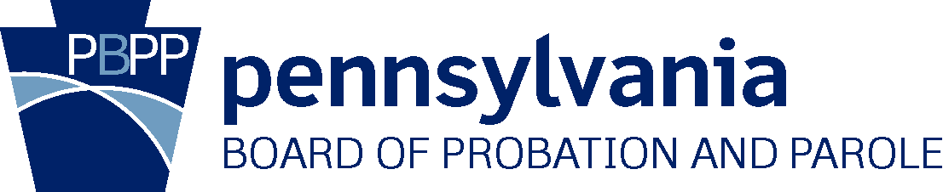

Pennsylvania Interstate State Council Meeting
March 25, 2021

State Council Members in attendance:
Linda Rosenberg, PA Interstate Commissioner/PPB Board Member
April Billet-Barclay, Deputy District Court Admin – Director of Probation Services, York
Francis Chardo, Dauphin County District Attorney
Anne Cornick, Deputy General Counsel, Governor’s Office of General Counsel
Edward Marsico, Jr, Judge in the Court of Common Pleas, Dauphin County (from 2:39 PM)
Todd Stephens, State Representative

Other Attendees:
Charles Eckert, Parole Manager of Interstate Services Division’s Parole Supervision & Retake Unit
Timothy Holmes, Acting Chief Counsel, DOC
George Little, Executive Deputy Secretary for Community Corrections, DOC
John Manning, Deputy Chief Counsel, PPB
Matthew Reed, Parole Manager of Interstate Services Division’s Incoming Unit
Paul Scott, Bureau Director for Central Services
Margaret Thompson, Deputy Compact Administrator, Director of Interstate Services Division
Thomas Williams, Recorder, Interstate Services Division
Minutes
- Call to Order and Introductions
  - The meeting having opened online via Zoom at 1:30 PM, Commissioner Rosenberg acknowledged quorum achieved, and called the Interstate State Council meeting to order at 1:45 PM. All parties noted above (except Judge Marsico) were online at that time.
  - Council members and guests introduced themselves and briefly reviewed the agenda.

- Approval of Minutes
  - Commissioner Rosenberg entertained a motion by Director Billet-Barclay to approve the minutes of the PA Interstate State Council meeting of March 10, 2020.
    - DA Chardo seconded the motion.
    - The motion carried unanimously.

- Application Fee
  - Commissioner Rosenberg opened the floor to Director Thompson, who briefly reviewed the history of the Interstate Application Fee, and reviewed assessment and disbursement to PA counties, noting the effect of the COVID-19 crisis on application ebbs and flows for the last year.
  - Commissioner Rosenberg entertained a motion by Director Billet-Barclay to maintain the Application Fee as $125.00.
    - DA Chardo seconded the motion.
    - The motion carried unanimously.
  - Commissioner Rosenberg entertained a motion by Deputy General Counsel Cornick to maintain full disbursement of the funds collected from the Application Fee to PA counties.
    - Rep Stephens seconded the motion.
    - The motion carried unanimously.
- Compact Rule 2.111 and COVID-19
  - Director Thompson explained that early in the COVID-19 crisis, the Interstate Commission approved Compact Rule 2.111, which did not suspend any of the rules of the Compact, but did suspend the timeframes associated with the rules. Director Thompson noted that it was anticipated that Rule 2.111 would be rescinded on April 1, 2021.
  - Director Thompson outlined the practical ramifications of COVID-19 on Interstate Services operations, especially noting an initial increase in the rate of rejected interstate transfers, noting the number of transfers decreased particularly in April – July, 2020, but that the volume of transfers is slowly returning to pre-COVID levels.

- Dashboards and Compliance
  - Parole Manager Reed, who reviewed PA’s compliance rate for audited Interstate Compact activities via “dashboard reports,” explained that for all audited activities, signatories are required to achieve a minimum rate of 80% compliance. It was noted that PA’s score is below the minimum acceptable rate for the submission of Requested Progress Reports within 30 days. PA’s compliance was at 76.67%, in comparison to the national average of 92.15%.
  - Parole Manager Reed explained the mechanics of the “dashboard reports” and their utility for identifying strengths and targeting weaknesses in operations.
  - Parole Manager Eckert provided background concerning the handling of Violation Reports for State Parolees and the status of transports for retaking of violators.

- Rule Proposal, 2021 Annual Business Meeting
  - Director Thompson discussed her role as an ex-officio member on the Interstate Commission’s Rules Committee, and reviewed a draft of a proposed rule concerning revised warrant timeframes.

- DNA Legislation Update
  - Parole Manager Reed briefly reviewed the history of PA’s Act 147-2018 and associated PA legislation concerning DNA collection for supervised offenders, and explained the new protocol for determination of DNA collection for Interstate offenders. Earlier in 2021 this task was absorbed mainly by Field Services staff, and training was coordinated with Field Training Agents.
  - Parole Manager Reed elaborated on the mechanics of statutory equivalencies between state criminal codes, and briefly described the history and ongoing challenges of achieving compliance with PA’s DNA laws.
  - Director Billet-Barclay sympathized, noting that due to COVID-19, her own office could not achieve compliance per the timeframes stipulated in PA’s DNA laws.
- Training
  - Director Thompson discussed the advantages and challenges of upcoming “Virtual” Basic Training Academies (BTA), to be scheduled and overseen by PCCD.
  - Director Thompson also discussed the upcoming Criminal Justice Advisory Board Conference, arranged by the PA Commission on Crime and Delinquency, to be held virtually on April 20-22, 2021.

- At 2:39 PM, Judge Marsico joined the meeting.

- New and Old Business
  - Commissioner Rosenberg opened the floor for new and old business. No new or old business was brought before the Council.
- Adjournment
  - Commissioner Rosenberg entertained a motion by Director Billet-Barclay to adjourn.
    - DA Chardo seconded the motion.
    - The motion carried unanimously.

The meeting concluded at 2:45 PM.

