Florida State Council for Interstate Adult
Offender Supervision Meeting Minutes
Tallahassee, FL
January 25, 2023
9:00 am – 2:00 pm

Council Members in Attendance:
Joe Winkler, Adrian Soud, Tommy Ford, Frank LeDee

Council Members Not in Attendance:
Pat Tuthill, Keith Perry

Council Guests in Attendance:
Sharon Davis, Tim Strickland, Chris Lane, Maria Dinkins, Lisa Kinard, Becky Choquette, Suzanne Hamilton

Opening Comments: Joe Winkler began meeting at 9:08 am, Becky Choquette called roll, quorum present

Welcome, Joe Winkler
- Joe Winkler, Assistant Secretary of Community Corrections, Chairperson for Florida’s State Council of Interstate Adult Offender Supervision

Recap from Last Meeting, Joe Winkler
- Tallahassee Meeting (March 9, 2022)
- 7 motions passed at last meeting
  - Passed a motion to establish an application fee
  - Passed a motion to establish an effective date of July 1, 2022
  - Passed a motion to establish the amount of the fee to be $100
  - Passed a motion to establish when offender is to pay the fee bring upfront before they leave FL
  - Passed a motion to establish how long an application fee is valid for 120 days
- Since July 1, 2022, the application fee has collected $202,180.69 as of meeting date

State Council Workshop, Tim Strickland
- South Region Meeting Update
  - Two rule proposals approved
    - New Rule 4.101-1: Offender Electronic Monitoring in Receiving or Sending State
    - Amendment to Rule 5.101-2: Discretionary Process for Disposition of Violation in the Sending State for a New Crime
- Annual Business Meeting in New York Update (September 26-28, 2022)
  - Due’s increase was approved
    - 5.25% dues increase for FY2024 – 2028 then 3% annually
- Application Fee Update
  - $181,367.21 collected July-December 2022
  - Net estimate for FY2022-2023 is $333,500.00
- Funds Available to go to 8% general revenue, state dues, a one-time reserve amount and travel expenditure
- Actions Needed
  - Passed a motion to establish use of funds for retaking
  - Passed a motion to establish an effective date
    - July 1, 2023
  - Passed a motion to establish a review process for approval of requests
    - FDC shall establish a review process approving requests for Sheriff’s to use funds and how, will work with legal on coming up with a process to include a 60-day time limit
  - Passed a motion to establish the reimbursement amount
    - Flat fee table (see below) per state based upon distance of travel from FL, contingent upon legislative approval and availability of funds
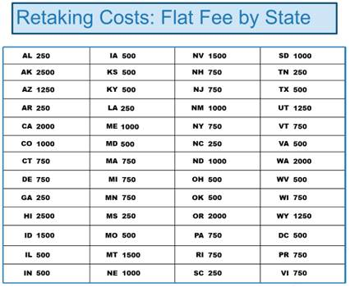
  - Passed a motion to establish a minimum availability of funds
    - Reserve in FDC account for $50,000 for FY2023-2024

Next Meeting – Date/Location; Objectives, Joe Winkler
- Wherever in the state
- In person or Virtual
- Possibly before July 1, 2023

Closing Comments:
- Look at calendars for next quarterly meeting

Meeting adjourned at 11:19 pm

